Information blocking requirements on the horizon
In April 2021, the Office of the National Coordinator for Health Information Technology’s (ONC) rules on information blocking went into effect. Information blocking is defined as practices that are likely to interfere with, prevent or materially discourage the access, exchange, or use of electronic health information (EHI). Physicians, hospitals, electronic health record (EHR) vendors, health information exchanges (HIE) and health information networks (HIN) are all subject to ONC's regulations and are referred to as "Actors." Actors whose actions are likely to interfere with the access, exchange, or use of EHI could be considered information blockers and subject to penalties or disincentives. EHR vendors and HIE/HINs can receive up to $1 million in civil monetary penalties per violation. Penalties and other "disincentives" for physicians have yet to be determined by the U.S. Department of Health and Human Services (HHS). We are expecting a proposed rule on disincentives in late 2022. For now, physicians participating in the Promoting Interoperability Program could see an impact to their Centers for Medicare & Medicaid Services Quality Payment Program incentives if they are found to be information blockers.
Since April 2021, information blocking requirements have been focused on a narrow subset all EHI. While Actors are encouraged to send the full set of EHI upon request, they are only responsible to provide a limited subset of health data called the United States Core Date for Interoperability (USCDI). The USCDI accounts for most of the common information you would likely find in a medical record, including a patient’s lab results, vital signs, clinical notes, allergies, and procedures. The USCDI is a federally defined requirement that all EHR systems must meet. However, starting October 6, 2022, HHS’ information blocking requirements shift to the entire EHI. After October 6, physicians and other Actors will be responsible for the access, exchange, or use of the full EHI requirement and no longer limited to just the USCDI.
What is EHI?

EHI is defined as electronic protected health information (ePHI) to the extent that it would be included in a designated record set (DRS). The DRS is defined within the Health Insurance Portability and Accountability Act (HIPAA). A DRS is a group of records maintained by or for a HIPAA covered entity (e.g., physician or hospital) that is: 1) the medical records and billing records about individuals maintained by or for a covered health care provider; 2) the enrollment, payment, claims adjudication, and case or medical management record systems maintained by or for a health plan; or 3) used, in whole or in part, by or for the covered entity to make decisions about individuals.

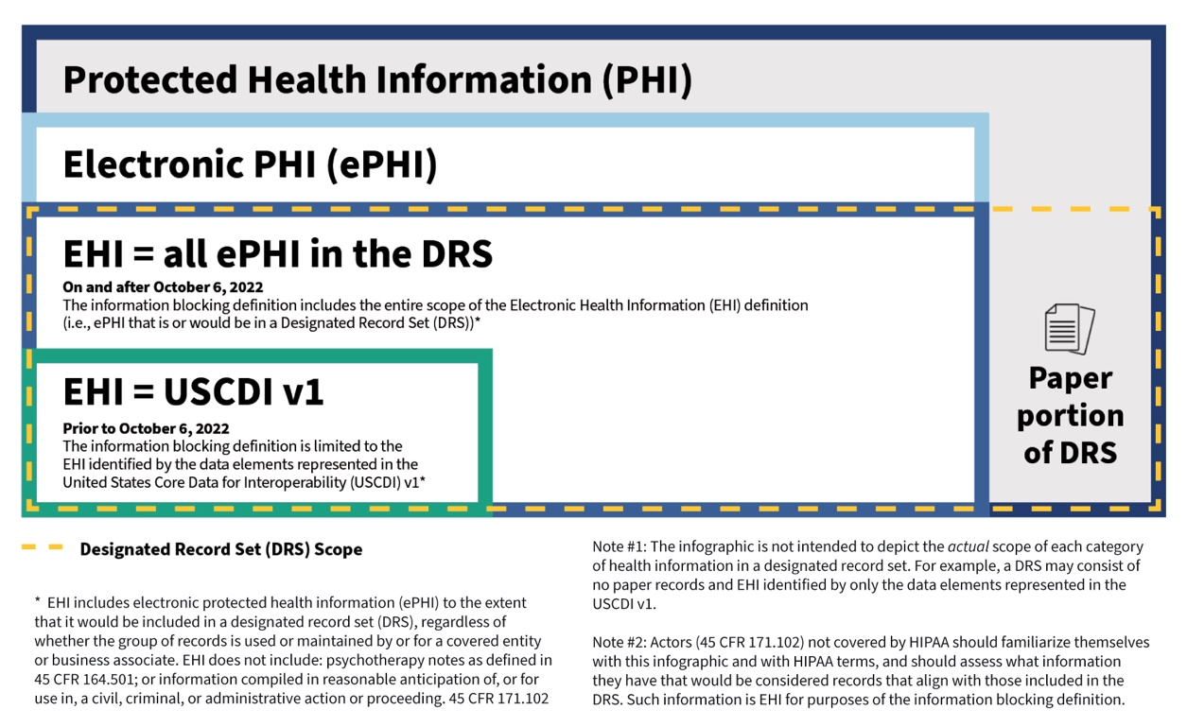
Source: HHS
The EHI definition incorporates terms (ePHI and DRS) defined by HIPAA. The definition of EHI, however, specifically excludes psychotherapy notes as defined in the HIPAA Rules and information compiled in anticipation of legal proceedings. EHI relies on the electronic part of what the HIPAA Rules define as the DRS.
HHS has created several resources (listed below) to assist in better understanding EHI. However, there is not a consensus across Actors, individuals, and other EHI requestors about the definition of EHI nor is there widespread availability of the technologies needed to support EHI access, exchange, or use. HHS has created several exceptions for situations where an Actor cannot or should not release EHI. While it is important to understand each of these exceptions fully, the “Infeasibility” and “Content and Manner” exceptions will likely a play major role when you or your EHR cannot provide the full EHI to a requestor, or if there is a discrepancy the interpretation of EHI.
What does this mean for me and my medical practice?

The first step is to make sure your practice has implemented a process to evaluate and comply with the information blocking requirements. The AMA has created a two-part educational resource to help you understand what information blocking is and how to comply. The AMA has also created a learning module that provides continuing medical education (CME) credit.

Second, you are not alone. Your EHR vendor is also an Actor under the information blocking regulations. Since April 2021, your EHR vendor should have enabled you, your patients, and other requestors to access at least the USCDI. By December 31st, 2022, all EHRs are required to provide their customers new technology that better enables access to EHI. Your EHR vendor is also likely planning for the full EHI requirement in October. In addition to reviewing your information blocking compliance policies and procedures, you should contact your EHR vendor to find out how they are preparing to assist you and your practice in meeting the October 6 EHI deadline.

Due to the complexity of HHS’ regulation and lack of clarity around EHI, it is likely that each Actor, e.g., physician practice, EHR vendor, hospital, etc., will interpret EHI differently. For instance, a hospital may request the full EHI on one of your patients but expect a slightly different set of records than you can make available. You may also see an increase in requests from patients seeking their EHI using personal digital health applications. Make sure to raise this issue with your EHR vendor and consider developing policies and procedures at your medical practices to address this issue before it comes up. The AMA is actively engaged with HHS to address the shortcomings of its rules and is urging flexibility in HHS’ enforcement of information blocking.

Below are resources to help you and your medical practice prepare for the upcoming EHI requirements.

HHS resources

- Information blocking overview
- EHI blog post
- Understanding EHI
- EHI frequently asked questions
- Information blocking exceptions

AMA resources

- Part one—What is information blocking?—defines information blocking, outlines key terms, illustrates information blocking practices and a summarizes exceptions.
- Part two—How do I comply with info blocking and where do I start?—provides a roadmap for compliance, including questions to consider, factors for maintaining a compliance program and next steps.
- CME module “Information Blocking Regulations: What to know and how to comply” accessible through the AMA Ed Hub™ online learning platform.

